**DPR Industrial Products**

**36 – Sujan Bhawan, Opposite – Police Line, Shivaji Nagar, Jalore – Rajasthan-343001**

**M/s.**

**Rajasthan.**

Dear Sir,

We would like to introduce us as an official agent of HESHENG MACHINE Co. LTD. [www.chinahesheng.com](http://www.chinahesheng.com) , we have started our sales and service office in Jalore, Rajasthan and soon will be spreading all over India. Our Technician and engineers are well trained from CHINA HESHENG Company. Our company is focused for quality service and customer’s trust.

Our company work and services

* Full Installation guidance
* 1 year free service
* Spare parts 6 months warranty
* Spare parts, Segment and Blades will be available at any time.

We DPR Industrial Products have been appointed to sell the machinery built by Hesheng Machine. This company makes the finest cutting machine in China. These machines will be a great inclusion to your companies since their output is tremendous in the long term. The perfection and output level of these machines will be a great addition to your companies. Hesheng machinery uses the international advanced technology, selects the high quality import spare parts, mechanical outlook artistic, the ease of operation security, the performance is stable, is in each kind of machinery first choice equipment.

We are offering different type of Multi blade Cutter, Edge cutting and polishing machine.

Besides the Four machines shown below, we also have other machines you can find out about in the website, for more information you can visit the link: <http://stonemachines.org/>

Some of our esteemed customers are Sriram Granites Jalore, Nice exports Jalore, Cosmo Impex Abu Road and Anant Stones Abu Road.

**DZQ-1600 stone cutting machine (Multi-blade Hydraulic Stone Cutter)**

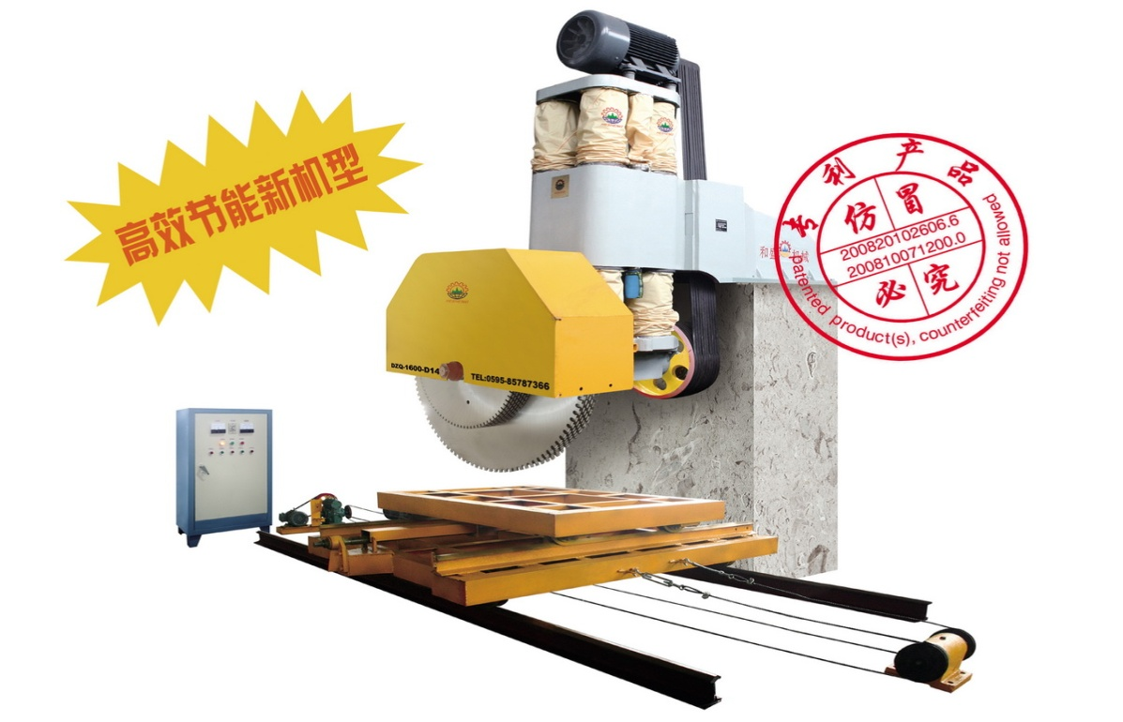

[**The DZQ-1600 Hydraulic Stone Cutter**](http://www.youtube.com/watch_popup?v=kgtsR4tGWV0&vq=medium)**is a multi-blade block saw for sawing kinds of stone blocks into slabs of varying thickness with up to 22 pc of diamond saw blades at the mostly..  
      The structure of such machine featured of simple and functional, is made up of a sturdy welded stabilized cast iron & steel to ensure maximum stability and utmost precision during sawing.  
      The up/down system is setup of Four hydraulic pressurize column, to ensure maximum protection against rust. Patented Lubrication System can vastly reduce maintenance frequency and maintenance costs which means a perfectly block cutter compared with traditional same kind of machine.**

**DNWQ-400(600) Bridge Edge cutting machine**

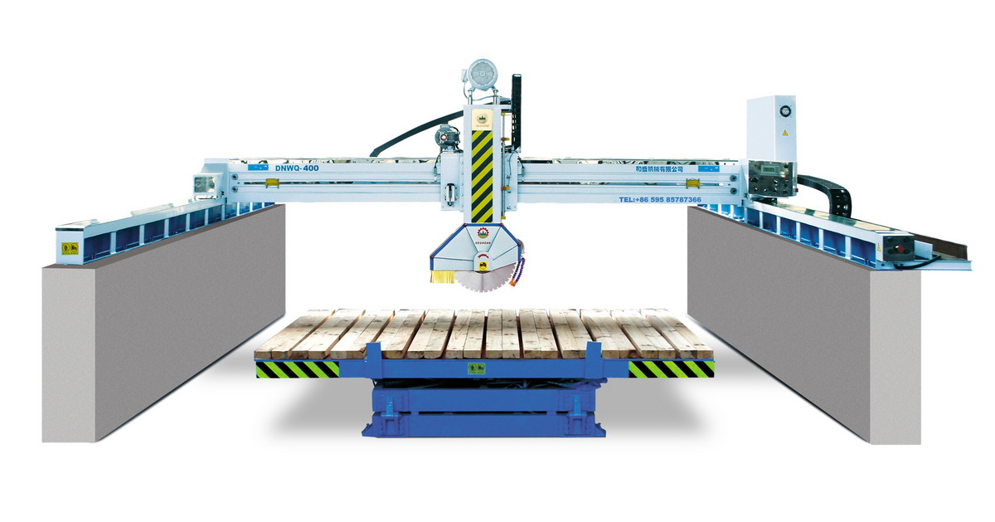

**Machine suited to all workshops for production of worked marble and granite.** **LCD graphics monitor to view English programme data.** **Right/left movement, translation of bridge, up/down movement of head, required bench rotation automatic and manually controlled. Separate ampermometer for regulating right/left sliding speed.**   
**Worktable tilts up by 85°for loading and unloading slabs.**   
**Hydraulically tilting head from 45°for marble/granite cutting.(optional)**   
**Automatic and programmable rotating can be blocked in every positions between 0°-360°or (optional).** **Electronically controlled inverter for all required speeds (optional)**   
**hydraulically tilting head**

|  |  |  |  |
| --- | --- | --- | --- |
| **Name** | **DNWQ-400** | **DNWQ-600** | **Unit** |
| **Max. working dimensions(LxWxH)** | **3200X3200X80** | **3200X3200X180** | **mm** |
| **Blade diameter** | **350-400** | **400-600** | **mm** |
| **Table dimensions (LxW)** | **3200X2000** | **3200X3200** | **mm** |
| **Table tilting degree** | **0-85** | **0-85** | **Degree** |
| **Table rotating degree** | **90** | **0 45 90 360** | **Degree** |
| **Main motor power** | **15** | **15** | **Kw** |
| **Water consumption** | **4** | **4** | **M3/h** |
| **Overall dimensions(LxWxH)** | **6000X5000X2800** | **6000X5000X2800** | **mm** |

**HSGJ-1600 Bridge cutting machine (Hydraulic Bridge Saw)**

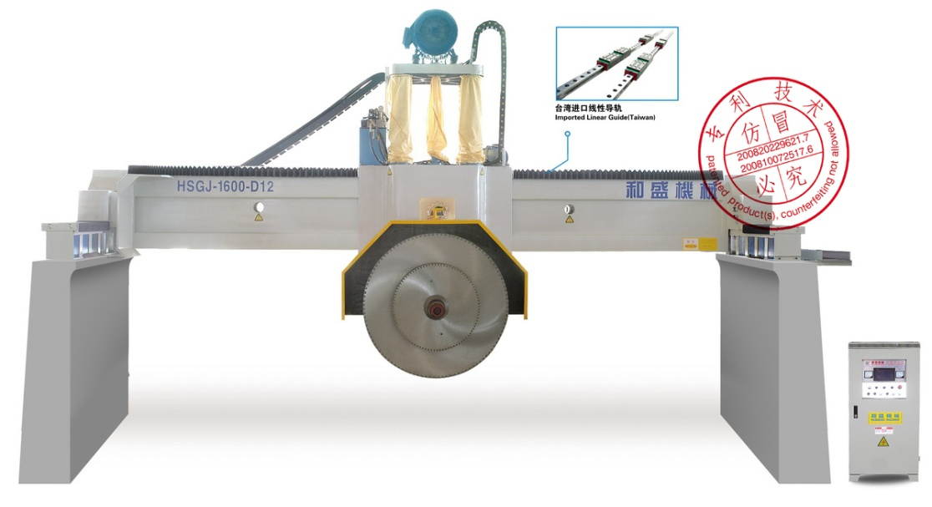

This machine gives improved cutting stability and perfection. This machine is the best and most stable machine ever made in China. Brilliant output in the long term and will give plenty of profit.

This Machine can hold up to 12 blades and comes in two versions.

HSGJ-1600 – D8 and HSGJ-1600 – D12 models.

|  |  |  |  |
| --- | --- | --- | --- |
| Model | D8 | D12 |  |
| Max. number of blades | 8(1650x4+980x4) | 12 | P |
| Max. blade diameter | 2500 | 3000 | mm |
| Crossbeam length | 7500 | 8000 | mm |
| X-axis | 3500-4300 | 3500-4800 | mm |
| Y-axis | 2300 | 2500 | mm |
| Z-axis | 1050-1200 | 1050-1400 | mm |
| Spindle drive motor | 45 | 55 | kw |
| Water consumption | 14 | 20 | M3/h |
| Overall dimension | 8700x4500x6500 | 9200x5000x6800 | mm |
| Gross weight | Approx 13.5 | Approx 20 | T |

**ZDMJ-8T Automatic Polishing Machine**

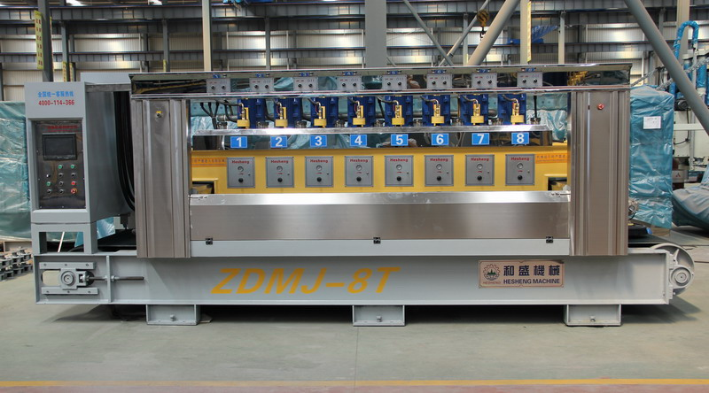

This Machine gives up to 90 Degree Finishing and best technology for fast production.

The machine is made by standard castings and steel, branded electrical equipment made in German, Japan and Taiwan.

This machine can also automatically identify the shape of tile, so that each polishing disc (polishing head) could automatically lift and lower according to the identified shape of tile and conduct tracking records for tile polishing at the same time.

|  |  |  |
| --- | --- | --- |
| Name | ZDMJ-8T | Unit |
| The number of grinding | 8 | N |
| Thickness of the effective work | 15-50 | mm |
| Effective working width | 600-1050(add width 1250) | mm |
| Belt feed rate | 0.8-3.0 | m/min |
| Grinding motor power | 7.5 | kw |
| Total power | 65 | kw |
| Water consumption | 10 | M3/h |
| Dimensions | 5.3x1.9x2.2 | m |